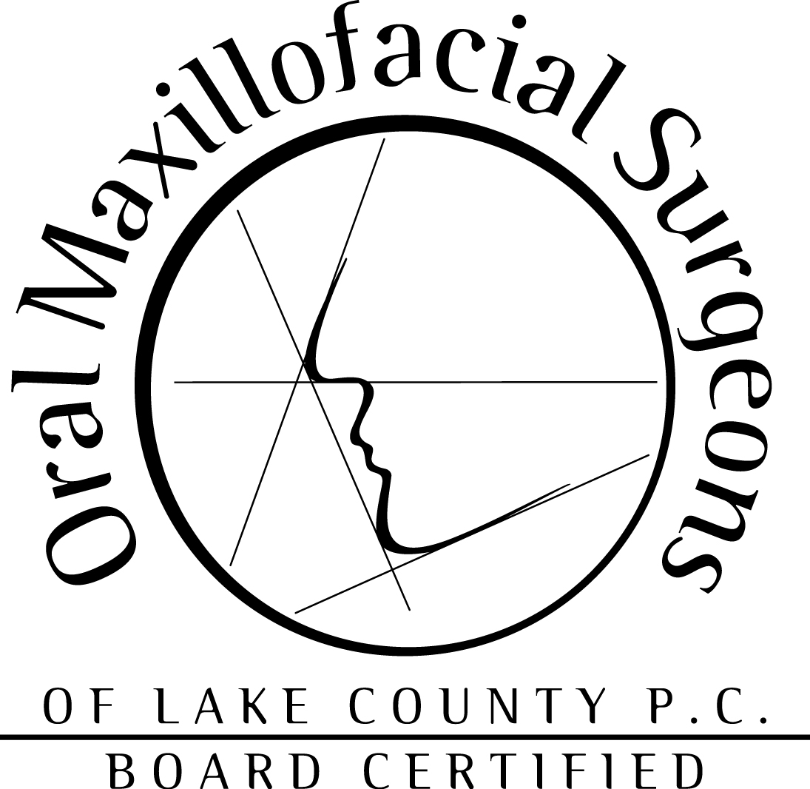

Dr. Fabian LaTocha

PATIENT CONSENT FORM AND ACKNOWLEDGEMENT OF RECEIPT OF NOTICE OF PRIVACY PRACTICES

Our Notice of Privacy Practices provides information about how we may use and disclose protected health information about you. You have the right to review our notice before signing this consent. As provided in our notice, the terms of our notice may change. If we change our notice, you may obtain a revised copy by contacting our Business Office.

You have the right to request that we restrict how protected health information about you is used or disclosed for treatment, payment, or health care operations. We are not required to agree to this restriction, but if we do, we are bound by our agreement.

By signing this form, you consent to our use and disclosure of protected health information about you for treatment, payment, and health care operations, including leaving messages on your home, cell and/or work answering machines. You have the right to revoke this consent, in writing, except where we have already made disclosure in reliance on your prior consent.

Please complete below: I give authorization to the doctors and staff of Oral & Maxillofacial Surgeons of Lake County to discuss my medical and/or financial information with the following people:

Name Relationship Phone

(1) __________________ ________________________ ________________

(2) __________________ ________________________ _________________

(3) __________________ ________________________ _________________

I understand that photographs, videotapes, digital or other images may be recorded to document my care, and I consent to this. I understand that Dr. Fabian LaTocha will retain the ownership rights to these photographs, videotapes, digital or other images, but that I will be allowed access to view them and obtain copies. I understand that these images will be stored in a secure manner that will protect my privacy and that they will be kept for the period of time required by law as outlined in Dr. LaTocha’s policy. Images that identify me will be released and/or used outside the office only upon written authorization from my legal representative or me.

In signing this form, I acknowledge having reviewed/received a copy of this office’s Notice of Privacy Practices and also give my consent to the above.

______________________________ ____________________________________ _____________
Please Print Name Signature Date

