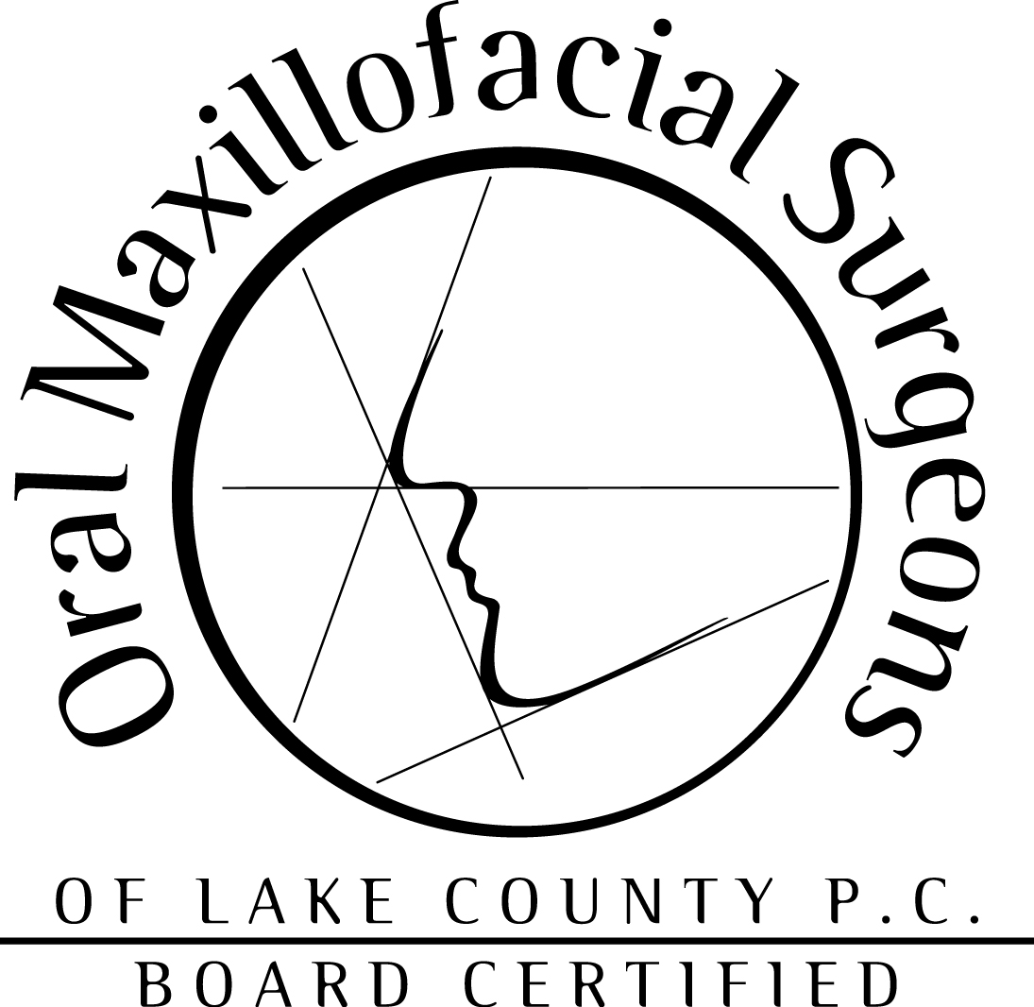

Dr. Fabian LaTocha

HIPPA NOTICE OF PRIVACY PRACTICES

THIS NOTICE DESCRIBES HOW MEDICAL/DENTAL INFORMATION ABOUT YOU MAY BE USED AND DISCLOSED AND HOW YOU CAN GET ACCESS TO THIS INFORMATION. PLEASE REVIEW IT CAREFULLY.

Effective Date: April14, 2003

WHO WILL FOLLOW THIS NOTICE:

This notice describes our office’s practices and that of:

- Any health care professional authorized to enter information into your treatment chart.

- All areas of the office.

- Any office member we allow to help you while you are in the office.

- All employees, staff and other office personnel.

- All these entities, sites and locations follow the terms of this notice; Dr. LaTocha’s office at 202 S. Greenleaf St., Ste. A, Gurnee, IL 60031. In Addition, these entities, sites and locations may share medical/dental information with each other for treatment, payment, or hospital operation purposes described in this notice.

OUR PEDGE REGARDING MEDICAL/DENTAL INFORMATION:

We understand that medical/dental information about you and your health is personal. We are committed to protecting medical/dental information about you. We create a record of the care and services you receive at the office. We need this record to provide you with quality care and to comply with certain legal requirements. This notice applies to all of the records of your care generated by the office, whether made by office personnel or your dentist. This notice will tell you about the ways in which we may use and disclose medical/dental information about you. We also describe your rights and certain obligations we have regarding the use and disclosure of medical/dental information

We are required by law to:

- make sure that medical/dental information that identifies you is kept private;

- give you this notice of our legal duties and privacy practices with respect to medical/dental information about you; and

- follow the terms of the notice that is currently in effect.

HOW WE MAY USE AND DISCLOSE MEDICAL/DENTAL INFORMATION ABOUT YOU

The following categories describe different ways that we use and disclose medical/dental information. For each category of uses or disclosures we will explain what we mean and try to give some examples. Not every use or disclosure in a category will be listed. However, all of the ways we are permitted to use and disclose information will fall within one of the categories

- For Treatment. We may use medical/dental information about you to provide you with dental treatment or services. We may disclose medical/dental information about you to other dentists, hygienists, laboratory technicians, or other office personnel who are involved in taking care of you at the office. For example, a dentist treating you for a periodontal condition may need to know if you have diabetes because diabetes may slow the healing process. If we need to disclose medical/dental information about you to people outside the office who may be involved in your care after have left the office, such as family members, we will ask for you oral authorization and note this in your chart.
- For Payment. We may use medical/dental information about you so that the treatment and services you receive at the office may be billed to and payment may be collected from you, an insurance company or a third party. For example, we may need to give your health plan information about treatment you received at the office so that your health plan will pay us or reimburse you for the treatment. We may also tell your health plan about a treatment you are going to receive to obtain prior approval or to determine whether your plan will cover the treatment.
- For HealthCare Operations. We may use and disclose medical/dental information about you for office operations. These uses and disclosures are necessary to run the office and make sure that all of our patients receive quality care. For example, we may us medical/dental information to review our treatment and services and to evaluate the performance of our staff in caring for you. We may also combine medical/dental information about many office patients to decide what additional services the office should offer, whether staff should be added, and whether certain new treatments are effective. We may also disclose information to dentist, laboratory technicians, and other office personnel for review and learning purposes.
- Appointment Reminders. We may use and disclose information to send you mailings reminding you that you have an appointment for treatment at the office. We also may leave telephone appointment messages on you home answering system, unless you advise us otherwise and choose to opt out (See Acknowledgement of Receipt of Notice of Privacy Rules).
- Treatment Alternatives. We may use and disclose medical/dental information to tell you about or recommend possible treatment options or alternatives that may be of interest to you.

- Health Related Benefits and Services. We may use and disclose medical/dental information to tell you about health related benefits or services that may be of interest to you.
- Individuals Involved in Your Care or Payment for your Care. If we see the need to release medical/dental information about you to a friend or family member who is involved in your care or pays for your care, we will ask for oral consent or authorization from ypou to do so, depending on the circumstances. HIPPA provides that the Privacy Rules shall not interfere with effective patient care.
- As Required By Law. We will disclose medical/dental information about you when required to do so by federal, state or local law.

SPECIAL SITUATIONS

- Worker’s Compensation. We may release medical/dental information about you for workers’ compensation or similar programs. These programs provide benefits for work related injuries or illnesses.
- Public Health Risks. We may disclose medical/dental information about you for public health activities. These activities generally include the following:

To prevent or control disease, injury or disability;

To report child abuse or neglect;

To report reactions to medications or problems with products;

To notify people of recalls or products they may be using;

To notify the appropriate government authority if we believe a patient has been the victim of abuse, neglect, or domestic violence. We will only make this disclosure if you agree or when required or authorized by law.

- Health Oversight Activities. We may disclose medical/dental information to a health oversight agency for activities authorized by law. These oversight activities include, for example, audits, investigations, inspections, and licensure. These activities are necessary for the government to monitor the health care system, government programs, and compliance with civil rights laws.
- Lawsuits and Disputes. If you are involved in a lawsuit or a dispute, we may disclose medical/dental information about you in response to a court or administrative order. We may also disclose medical/dental information about you in response to a subpoena, discovery request, or other lawful process by someone else involved in the dispute, but only if efforts have been made to tell you about the request or to obtain an order protecting the information requested.
- Law Enforcement. We may release medical/dental information if asked to do so by a law enforcement office:

In response to a court order, subpoena, warrant, summons or similar process;

To identify or locate a suspect, fugitive, material witness, or missing person;

In emergency circumstances to report a crime; the location of the crime or victims; or the identity, description or location of the person who committed the crime.

- Coroners, Medical Examiners and Funeral Directors. We may release medical/dental information to a coroner or medical examiner. This may be necessary, for example, to identify a deceased person or determine the cause of death
- National Security and Intelligence Activities. We may release medical/dental information about you to authorized federal officials for intelligence, counterintelligence, and other national security activities authorized by law.
- Inmates. If you are an inmate of a correctional institution or under the custody of a law enforcement official, we may release medical/dental information about you to the correctional institution or law enforcement official. This release would be necessary (1) for the institution to provide you with dental care; (2) to protect your health and safety or the health and safety of others; or (3) for the safety and security of the correctional institution.
YOUR RIGHTS REGARDING MEDICAL/DENTAL INFORMATION ABOUT YOU

You have the following rights regarding medical/dental information we maintain about you:

- Right to Inspect and Copy. You have the right to inspect and copy medical/dental information that may be used to make decisions about your care. Usually, this included medical, dental and billing records.

To inspect and copy medical/dental information that may be used to make decisions about your, you must submit your request in writing to 202 S. Greenleaf St., Ste. A Gurnee, IL 60031. If you request a copy of the information, we may charge a fee for the costs of copying, mailing or other supplies associated with your request.

- Right to Amend. If you feel that medical/dental in formation we have about you is incorrect or incomplete, you may ask us to amend the information. You have the right to request an amendment for as long as the information is kept by or for the office.

To request an amendment, your request must be made in writing and submitted to 202 S. Greenleaf St., Ste. A, Gurnee, IL 60031. In addition, you must provide a reason that supports your request.

We may deny your request for an amendment if it is not in writing or does not include a reason to support the request. In addition, we may deny your request if you ask us to ament information that:

Was not created by us;

Is not part of the medical/dental information kept by or for the office;

Is not part of the information which you would be permitted to inspect and copy;
or

Is accurate and complete.

- Right to an Accounting of Disclosures. You have the right to request an “accounting of disclosures.” This is a list of the disclosures we made of medical/dental information about you, not related to treatment, payment and health care operation of the office, which you did not specifically authorize.

To request this list or accounting of disclosures you must submit your request in writing to 202 S. Greenleaf St., Ste. A, Gurnee, IL 60031. Your request must state a time period, which may not be longer than six years and may not include dates before April 14, 2003. Your request should indicate in what form you want the list (for example; on paper, electronically).

- Right to Request Restrictions. You have the right to request a restriction or limitations on the medical/dental information we use or disclose about you for treatment, payment, or health care operations.

We are not required to agree to your request. If we do agree, we will comply with
your request unless that information is needed to provide you emergency treatment.

To request restrictions you must make your request in writing to 202 S. Greenleaf St., Ste. A, Gurnee, IL 60031. In your request you must tell us (1) what information you want to limit; (2) whether you want to limit our use, disclosure or both, and (3) to whom you want the limits to apply.

- Right to Request Confidential Communications. You have the right to request that we communicate with you about medical/dental matters in a certain way or at a certain location. For example, you can ask that we only contact you at work or my mail.

To request confidential communications, you must make your request in writing to 202 S. Greenleaf St., Ste. A, Gurnee, IL 60031. We will not ask you the reason for your request. We will accommodate all reasonable requests. Your request must specify how or where you wish to be contacted.

- Right to a Paper Copy of This Notice. You have the right to a paper copy of this notice. You may ask us to give you a copy of this notice at any time. Even if you have agreed to receive this notice electronically, you are still entitled to a paper copy of this notice.

To obtain a paper copy of this notice, please contact Barb Moore.

CHANGES TO THIS NOTICE

We reserve the right to change this notice. We reserve the right to make the revised or changed notice effective for medical/dental information we already have about you as well as any information we receive in the future. The notice will contain, on the first page, the effective date.

COMPLAINTS

If you believe your privacy rights have been violated you may file a complaint with the office or with the Secretary of the Department of Health and Human Services. To file a complaint with the office, you must submit your complaint in writing to 202 S. Greenleaf St., Ste. A, Gurnee, IL 60031.

You will not be penalized for filing a complaint.

OTHER USES OF MEDICAL/DENTAL INFORMATION

Other uses and disclosure of medical/dental information not covered by this notice of the laws that apply to us will be made only with your written authorization. If you provide us with an authorization to use or disclose medical/dental information about you, you may revoke that authorization, in writing, at any time. If you revoke your authorization, we will no longer use or disclose medical/dental information about you for the reasons covered by your written authorization. You understand that we are unable to take back any disclosures we have already made with your permission, and that we are required to retain our records of the care that we provided to you.

